CST 430 – Project 3

SSH Hardening, Negative Testing, and Operational Checks

Objective
In this demo, you will confirm the required Project 3 SSH hardening settings, perform one approved negative/security test, and practice the service and log checks you will use later for troubleshooting and for healthcheck.sh.

Before you begin
This demo assumes you already completed Unit 3 Demo 1. Before continuing, make sure all of the following are true:
- Nginx is installed and active on the Server VM.
- Your custom page is already being served from /data/app/site.
- The Server VM can load the page locally with curl http://localhost.
- The Client VM can already reach the page over HTTP from Demo Guide 1.
- You have a working user account on the Server VM that can run sudo.
The focus of this demo is refining the required hardening posture, showing one denied action, and learning the first commands to run when checking service health.

Part 1: Quick readiness check
Start with a short sanity check to confirm the system is still in the expected state before you make any new changes.

Step 1: Confirm Nginx is active on the Server VM
On the Server VM, enter:
systemctl is-active nginx
Expected output: active

Step 2: Confirm UFW is active on the Server VM
On the Server VM, enter:
sudo ufw status
You should see Status: active. If UFW is inactive, enable it before continuing.

Step 3: Confirm the client can still reach the page
On the Client VM, enter:
curl http://<server-ip>
Replace <server-ip> with the server host-only or internal lab IP address, not the NAT IP address. You should see the HTML for your custom page.
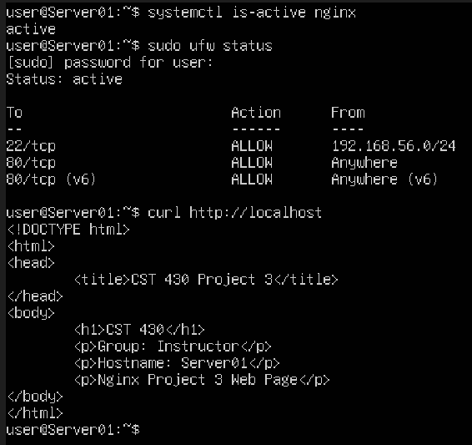

Part 2: Confirm the required SSH hardening settings
Project 3 requires a fixed SSH hardening posture. In this section, you will verify that root login is disabled and that only users in the admins group are allowed to SSH into the system.

Step 1: Open the SSH daemon configuration file
On the Server VM, enter:
sudo nano /etc/ssh/sshd_config

Step 2: Find or add the required settings
Inside the file, make sure these lines are present:
PermitRootLogin no
AllowGroups admins
If these settings already exist, verify that they match exactly. If a matching line is commented out with #, remove the # so the setting is active.
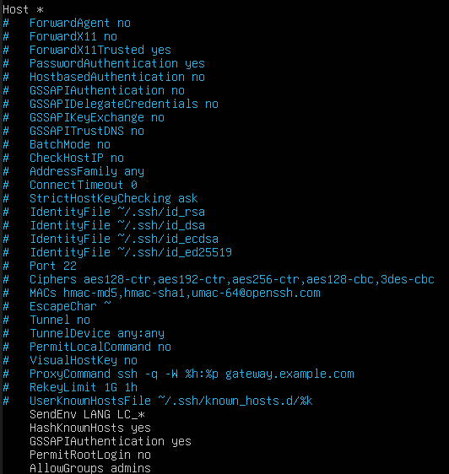

Step 3: Save and exit Nano
Press Ctrl + O, then Enter, then Ctrl + X.

Step 4: Test the SSH configuration syntax
On the Server VM, enter:
sudo sshd -t
If the syntax is valid, this command usually returns no output.

Step 5: Reload the SSH service
On the Server VM, enter:
sudo systemctl reload ssh

Step 6: Verify the settings again
On the Server VM, enter:
grep -E 'PermitRootLogin|AllowGroups' /etc/ssh/sshd_config
Your output should include:
PermitRootLogin no
AllowGroups adminsconfigss
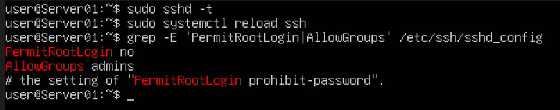
Important: If you are connected over SSH while making this change, do not close your current SSH session until you confirm the configuration still works.

Part 3: Demonstrate two approved negative/security tests
Project 3 requires two negative/security tests. In this guide, you will demonstrate a failed attempt to modify the deployed site content from a user account that should not have write access.

Step 1: Review the site ownership and permissions
On the Server VM, enter:
ls -ld /data/app/site
ls -l /data/app/site/index.html
Review the owner, group, and permissions before attempting the negative test.
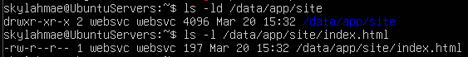

Step 2: Attempt an unauthorized write as your normal user
Use a user account that should not have write access to the deployed site content. To test this, enter:
echo "unauthorized change" >> /data/app/site/index.html
You should see a permission denied message.

Step 3: If needed, simulate the attempt with another user
If your current logged-in user unexpectedly has write access, use another user account that should not be able to modify the file. For example:
sudo -u <non_admin_user> bash -lc 'echo "unauthorized change" >> /data/app/site/index.html'
Replace <non_admin_user> with a user account that is not intended to modify the deployed site content.
If this write attempt succeeds, your ownership or permissions model is too permissive and should be reviewed before continuing.

Step 4: Understand why the attempt failed
The write should fail because the file ownership and permission model limits who may modify deployed site content. This demonstrates that your deployed site content is protected by a least-privilege ownership and permissions model.
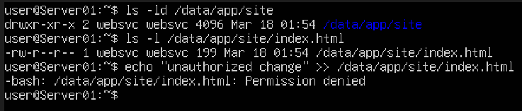

Step 5: Second negative/security test
You must also demonstrate a failed SSH login by a non-admin user, blocked connection attempt to a port not allowed by UFW, or other approved test for the final project submission. This guide does not walk through that test step-by-step. Use the SSH hardening settings from Part 2 and your knowledge from Project 1 to design and capture that evidence yourself.
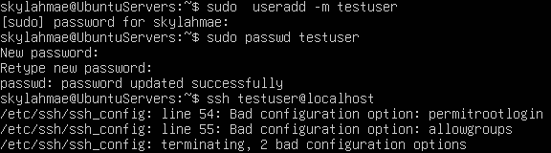

Part 4: Operational checks for service health
Below are some of the first commands an administrator should run when checking whether Nginx is healthy. These same checks will be useful later when you build healthcheck.sh.

Step 1: Check the Nginx service status
On the Server VM, enter:
sudo systemctl status nginx --no-pager

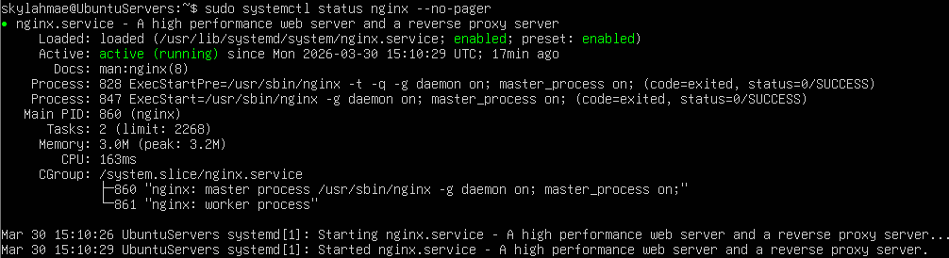

Step 2: Show recent Nginx logs
On the Server VM, enter:
sudo journalctl -u nginx --since "10 minutes ago"
This shows recent journal entries for the Nginx service.

Step 3: Confirm that port 80 is still listening
On the Server VM, enter:
ss -tulpn | grep ':80'
If the service is healthy, you should still see Nginx listening on port 80.

Step 4: Verify the firewall rule for HTTP
On the Server VM, enter:
sudo ufw status verbose
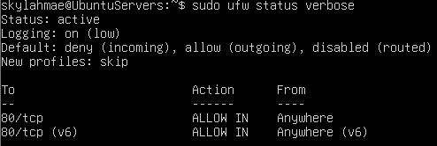
Look for a rule allowing 80/tcp. If UFW was already active, any new rule you added applies immediately.
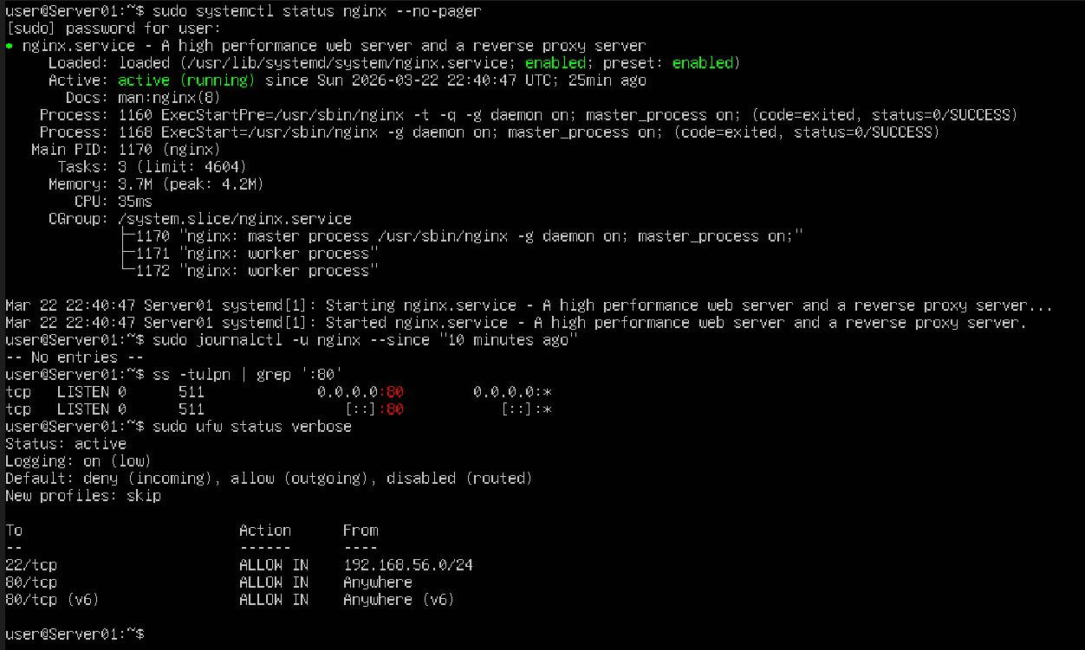

Common issues and fixes

Problem: sudo sshd -t reports an error
This usually means there is a typo or malformed line in /etc/ssh/sshd_config. Reopen the file, correct the error, save it, and run the syntax test again:
sudo sshd -t

Problem: the negative test does not fail
That usually means you tested with a user account that still has write access to the file. Check the ownership and permissions again and make sure you are testing from an account that should not be allowed to modify deployed content.
ls -ld /data/app/site
ls -l /data/app/site/index.html

Problem: the client could reach the page earlier, but now it cannot
Check all of the following on the Server VM:
systemctl status nginx --no-pager
sudo ufw status verbose
ss -tulpn | grep ':80'
Also verify that the Client VM is using the correct server host-only or internal lab IP address.

What you should have at the end of Demo Guide 2
- confirmed the required SSH hardening settings
- performed two approved negative/security tests
- practiced the main status, log, socket, and firewall checks for Nginx
- captured the evidence needed for the hardening, negative test, and operational checks of Project 3

